Project Phase 1: Lexical Analyzer for Tiny Language
Team members:
- Samy Magdy Reda ID: 324243037
- Stephanie Elsayed ID: 324243094
- Antonios Emile Nabil ID: 324260140
- David Osama Maher ID: 324243254
- Charle Joseph ID: 324240190

User Interface (UI):
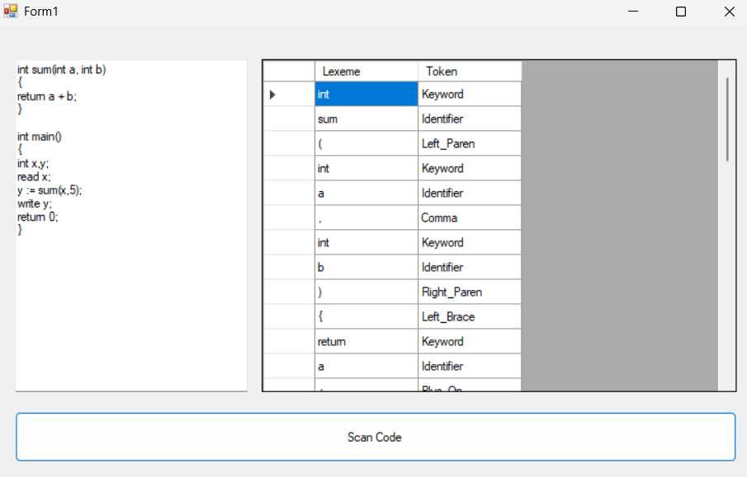
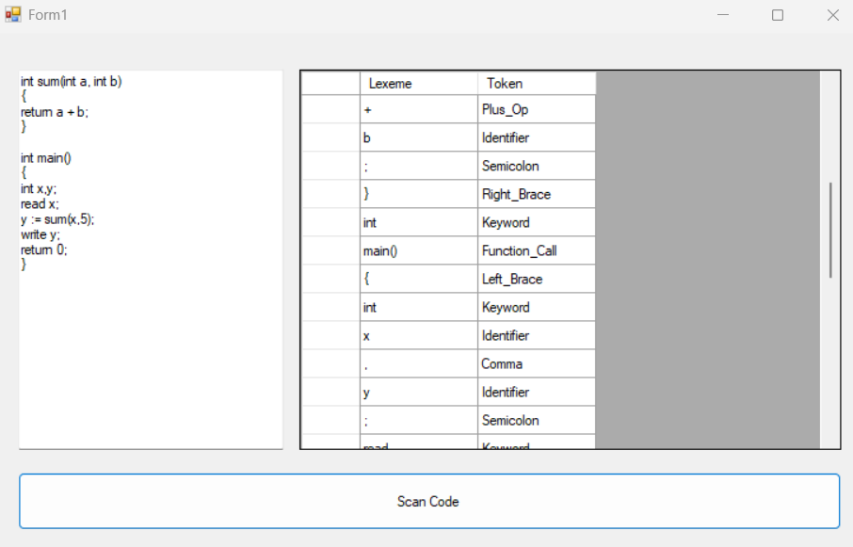
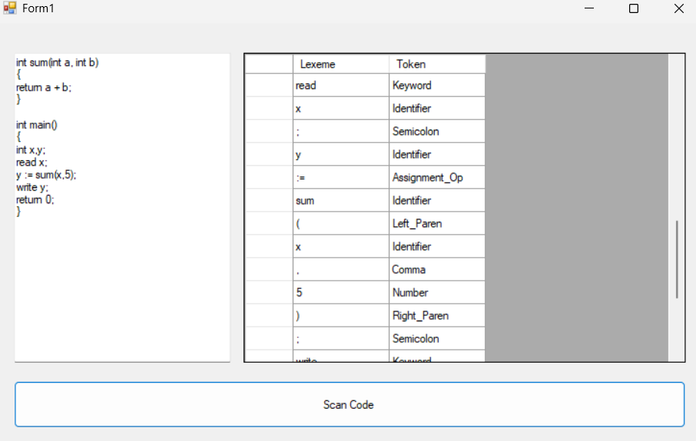
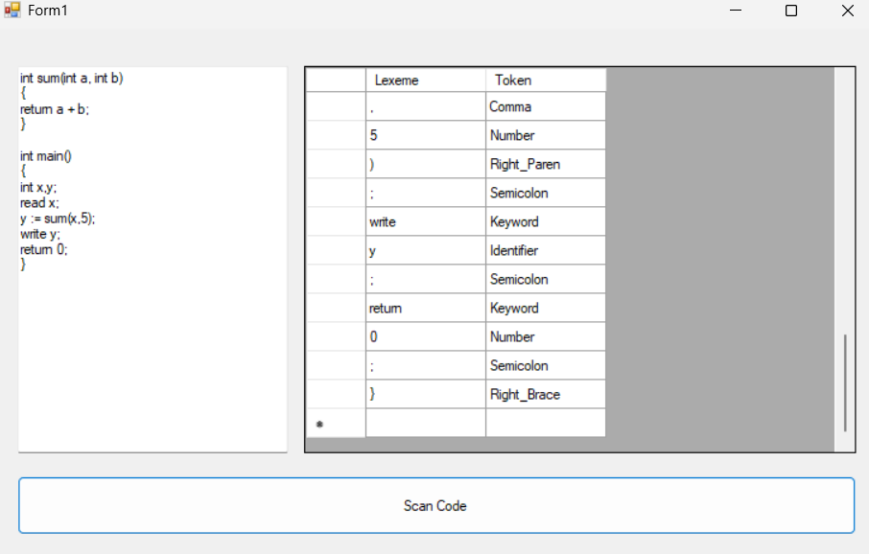

Git Hub Repository: https://github.com/samymagdi/Tiny-Language-Lexer.git

